TFL Journey Planner

I personally would like to base our design on this particular system due to its simplicity, a

Initially the system appears to be very raw offering users the ability to input the starting location and destination for desired journey. Recent searches are listed in a separate box below.

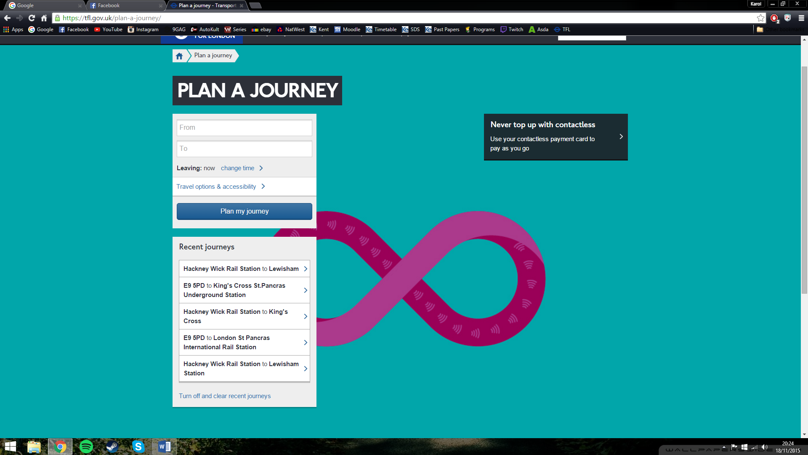

Clicking on “change time” expands the box slightly offering users to specify directly their desired departure or arrival time at a destination

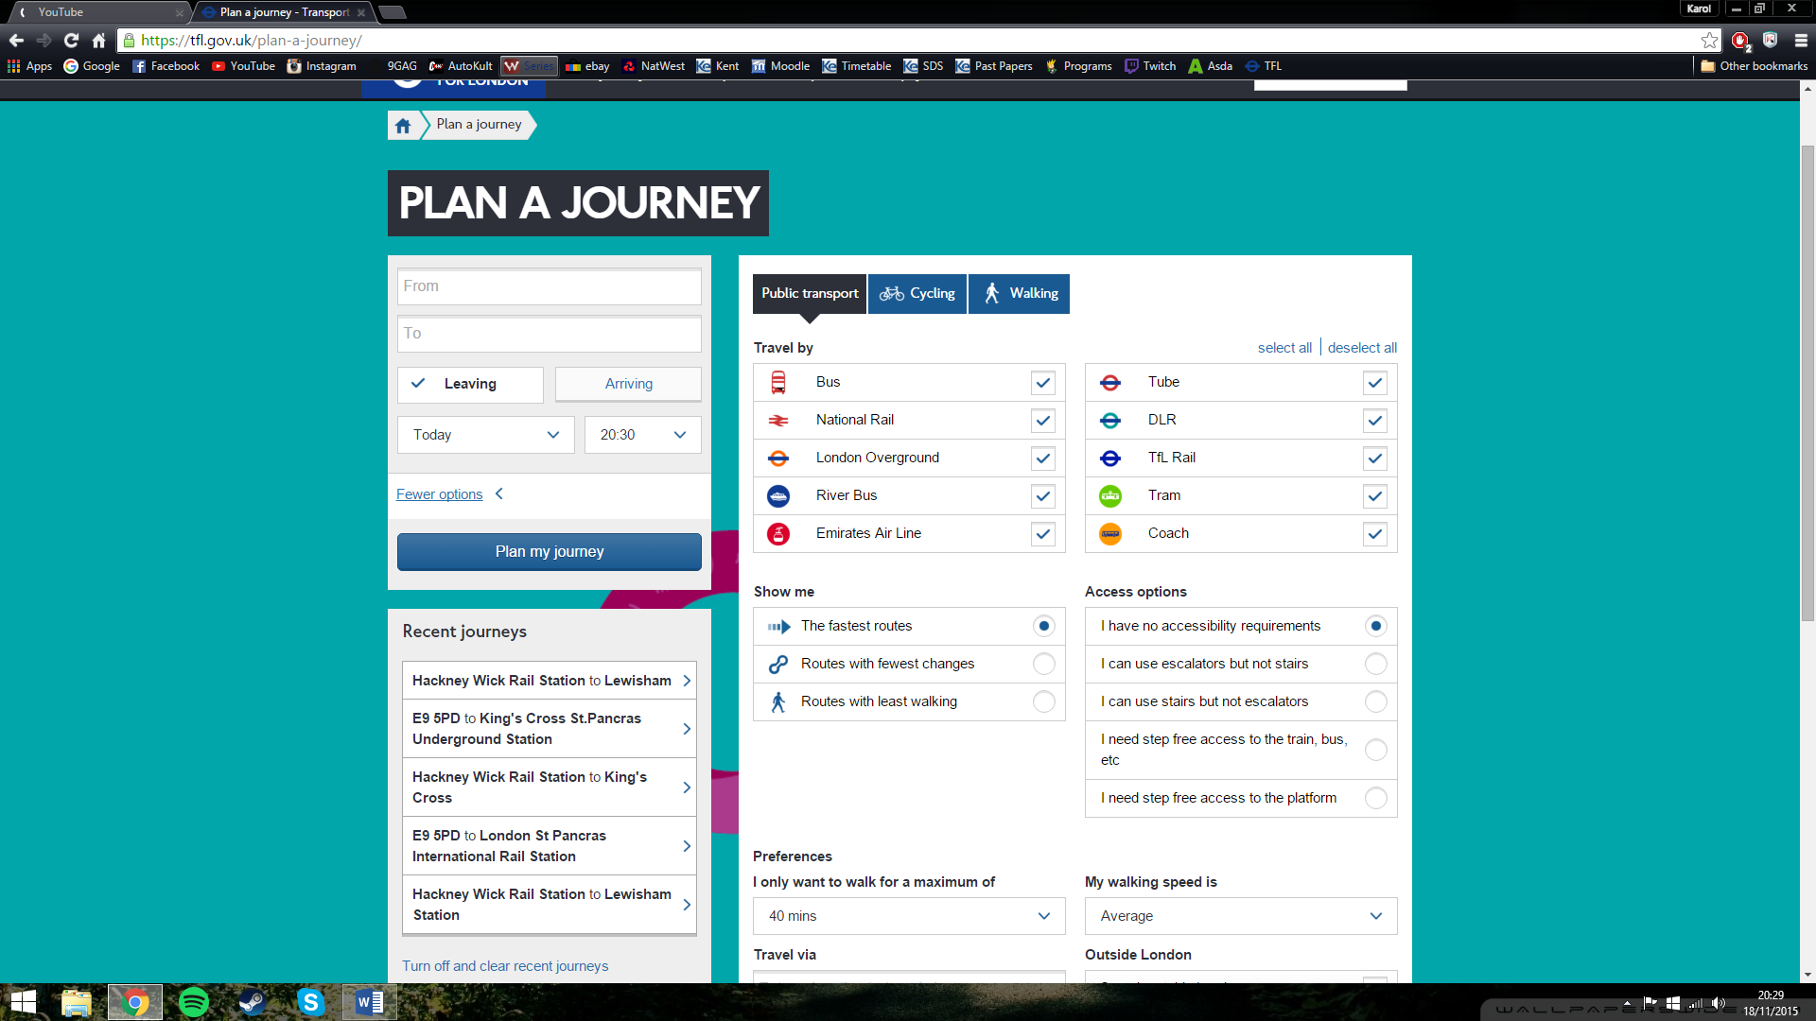

Clicking on “Travel options & accessibility” expands the interface offering users a much more advanced options.

Users can now choose to complete their journey entirely, by walking or cycling

